10 Trends Point the Way to Future Resort Development

Emergence of Adventure Sports Resorts

By Jeff Coy, ISHC

Tourism Review, June 2009 --- Ever since waterparks came indoors, under cover, and attached themselves to hotels, the hotel waterpark resort industry has continued to grow at an accelerating pace --- from 24% to 32% annually. And the average size of these waterpark resorts is getting bigger. In 2004, only one indoor waterpark over 50,000 sf opened. In 2005, three opened. But eight (8) indoor waterparks over 50,000 sf opened in 2006, and another eight (8) opened in 2007.

What’s the future of resort development?

Ten major trends point the way:

- Lodging, Recreation & Entertainment Concepts are Merging
- Long Weekends Are Replacing Long Vacations
- Multi-Generational Family Gatherings Are More Popular
- Projects Are Moving Toward Mixed-Use Resort Destinations
- Hotel Waterpark Resort Growth Is Accelerating
- Indoor Waterpark Projects Are Getting Bigger
- Adventure Sports Are Going Mainstream
- Demand Is Moving from Natural to Man-Made Facilities
- Every Outdoor Sport Will Have An Indoor Version
- New High-Tech Structures & Enclosures Cover Large Spaces Affordably

1. Lodging, Recreation & Entertainment Concepts Are Merging

In urban areas, we now see hotels, recreation, entertainment, sporting activities, shopping, convention centers and large-scale attractions being combined in mixed-use resort destination developments. For example:

- Kalahari Resort in Wisconsin Dells WI broke ground in May 2008 a $15 million indoor entertainment facility that includes a 24-lane bowling alley, 65-foot Ferris wheel, ropes course, a zip line and over 200 arcade games. Kalahari already has a 125,000 square foot indoor waterpark, 65,000 square foot outdoor waterpark, 125,000 square foot convention center and over 800 hotel rooms and condominiums.

- At Silver Mountain Resort in Kellogg ID, you can stay and ride a surf simulator in the new indoor waterpark and ride a gondola up to the top of the mountain for snow skiing in winter and mountain biking in summer. You can also buy a timeshare, condo or vacation home in the center of the action.

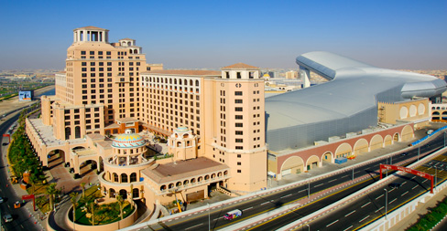
- At the Kempinski Hotel in Dubai, you can stay and play in the waterpark and ski on real snow indoors. See the Ski Dubai dome in photo at right.

- On Long Island NY, Riverhead Resorts is planning to develop 2,200 hotel rooms where you can stay and play in the indoor waterpark, ski on a 350-foot indoor man-made ski mountain and then raft down a whitewater river course.

- In Mesa AZ, the developers of Waveyard Adventure Resort are on track to build a destination resort that merges almost all of the lodging, recreation and entertainment concepts --- including 400-room hotel, indoor waterpark, retail space, whitewater rafting river, a deep scuba pool and a large wave pool.

In more rural settings, hotels and indoor-outdoor waterparks are being combined with golf courses, ski hills, conference centers, medical centers, casinos and residential projects as well as second home, vacation home and resort retirement communities.

2. Long Weekends Are Replacing Long Vacations

A recent USA Today article reported that the two week vacation is fast disappearing. Instead, employees are using their vacation days to extend weekends and take shorter breaks from the office.

Rising gas prices are partly to blame as well as mounting pressure for workers to be available to clients around the clock. And more dual income couples are finding it difficult to coordinate vacation schedules due to work demands. About 55% of vacationers will take several shorter weekend getaways instead of the traditional long summer retreat, according to a WNBC survey. This trend certainly explains the popularity of drive-to regional resorts and the rapid growth of indoor waterparks as part of hotels and resorts. High gas prices, dissatisfaction with the airlines and shorter getaways all contribute to the relative success of regional drive-to resorts compared to the national fly-to resorts.

3. Multi-Generational Family Gatherings Are More Popular

Unlike the typical vacation of the past that involved just Mom, Dad and the kids, older and younger generations are traveling together more. In a nation in which families often live in separate states, sharing a vacation is a way for grandparents, parents and children to book some quality time and make memories.

A recent poll of American Express travel agents found that 69% of them were booking trips for adult children and their parents. The same percent saw grandparents traveling exclusively with their grandchildren, and 67% planned trips for family and friends traveling together as one large group.

Several waterpark resorts with large villas (sleeping 12 to 20 people) reported that these popular units sell out first. As a result of togethering, as it is called, indoor waterparks are being designed for all ages and resorts are responding with packages to please all ages.

4. Projects Are Moving Toward Mixed-Use Resort Destinations

Mixed-use has come of age and is growing rapidly. It is one of the hottest product types in real estate. Almost every new hotel project includes a variety of components that create a destination for meeting, shopping, recreation and entertainment.

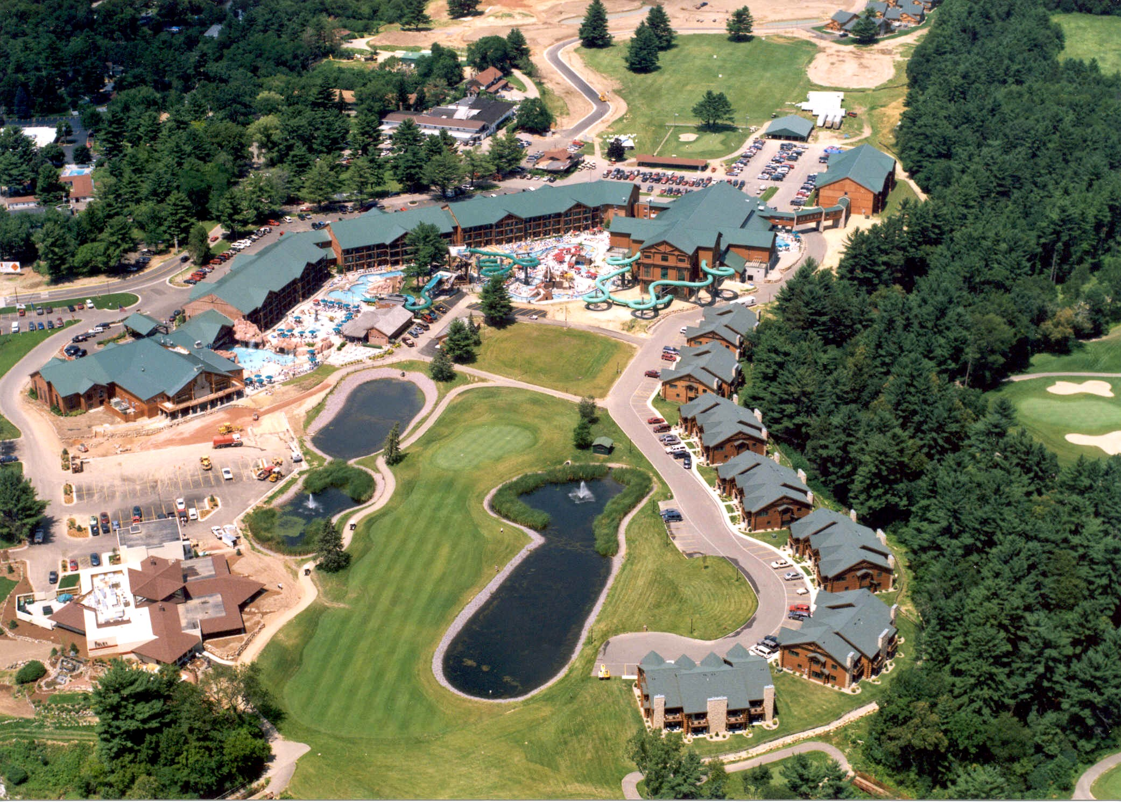

Why is mixed-use so popular among developers and lenders? Because all the components have a positive impact on each other and help to stabilize the entire project. Not all these impacts are fully understood by developers because mixed-use real estate projects are complex and require expertise in many different areas. However, almost everyone agrees that hotel owners are no longer content to have lodging generators nearby. They are designing and integrating these demand generators into destination projects that act as a strong magnet in the region.

Resort owners and developers will increasingly try to eliminate the seasonality and weather factors by designing resorts to capture year round revenues. They will do this by adopting the four-season strategy, by building recreational facilities for summer, fall, winter and spring, and by converting more outdoor spaces into flexible indoor-outdoor combinations.

5. Hotel Waterpark Resort Growth Is Accelerating

Hotels and resorts with indoor waterparks are a small but rapidly-growing segment of the lodging, recreation and entertainment business. Hotel waterparks are popular with families and hotel owners because they fill empty rooms at higher room rates than hotels without indoor waterparks.

The waterpark sector of the resort industry has experienced annual growth ranging from 22% to over 30% in each of the last seven years. Clearly, hotel waterpark resorts are not a fad but here to stay.

Every year the construction pipeline gets bigger. And hotel waterpark projects keep getting bigger in size. Many are part of mixed-use resort destination developments that include conference centers, recreation, entertainment, retail shopping, offices and residential units.

- Recently, the Kalahari Resort & Convention Center in Sandusky OH completed its expansion to become the largest hotel waterpark resort in the USA --- with 884 rooms and 173,000 sf of indoor waterpark under one roof.

- Chula Vista Resort in Wisconsin Dells is in the midst of a 4-year $200 million expansion. It recently topped the charts of the Top 10 Hotel Meeting Facilities with indoor waterparks in the USA --- with 150,000 sf of domed meeting space and 110,000 sf of indoor waterparks. Kalahari Resort in the Dells dropped to second largest (125,000 sf) meeting place with an indoor waterpark.

A hotel waterpark resort is just a hotel with a very expensive attraction, similar to having a golf course or conference center. While they can be expensive to build, the costs are small compared to their positive impact on hotel occupancy, room rates, room revenues and total guest spending.

6. Indoor Waterpark Projects Are Getting Bigger

The average size of a hotel indoor waterpark has been steadily getting bigger each year from 20,382 sf in 2002 to 24,452 sf in 2007. More and more hotel waterparks are adding meeting space to attract different types of customers during certain low periods throughout the year. And more hotel waterparks are part of larger mixed-use resort projects.

When deciding how big to build an indoor waterpark, conventional wisdom might tell a developer to build it slightly smaller than necessary. But in the hotel waterpark resort industry, just the opposite is true. “Bigger is better,” a philosophy adopted by numerous developers goes to the heart of the matter --- entertainment value. To encourage families with young children to drive up to 200 miles and spend more than $200 a night for a family suite, you have to offer high entertainment value. The smarter developers understand this.

In 2004, only one indoor waterpark over 50,000 sf opened. In 2005, three opened. But eight (8) indoor waterparks over 50,000 sf opened in 2006, and another eight (8) opened in 2007. Details are provided in the Hotel Waterpark Resort Industry Report and the Construction Report, produced annually by industry consultants Jeff Coy and Bill Haralson. www.jeffcoy.com

7. Adventure Sports Are Going Mainstream

Activities include surfing, skiing, boarding, paddling, rafting, kayaking, rock-climbing, rope-walking and skydiving. The challenge is to master the media, things like snow, water, waves, rapids, rocks, ropes and skydiving. Almost all of these activities that pit man against nature are seasonal, such as kayaking in spring, ocean surfing in summer and snow skiing in winter.

For the pure sporting enthusiast, a 30-something with a real job, it is often inconvenient and expensive to be in the right place at the right time --- when the ocean wave is perfect or the whitewater river is cresting.

While the purist may love the real thing, he or she can spend more time mastering their sport at man-made facilities, using artificial materials and simulators. For the novice, typically a teen or 20-something who wants to learn the sport, it requires a convenient facility that is close to home.


Let’s say you want to learn how to skydive.

You can look for the ideal location, near a military installation or general aviation facility with aircraft and a sport parachute club and wait for the perfect weather and availability of an aircraft and instructor to make your first jump.

Or you can go to Las Vegas and float on a column of air in a vertical wind tunnel to capture the sensation of free-falling at 120 miles per hour (www.flyawayindoorskydiving.com) or you check into the Skyrider Inn in Eloy AZ and schedule an hour in the wind tunnel at SkyVentureArizona. www.skyventureaz.com

With more and more man-made facilities, conveniently located close to home and work, where novices and enthusiasts alike can practice their skills more frequently, adventure sports are going mainstream and becoming part of mixed-use resort developments.

8. Trend from Natural to Man-Made Facilities

Many of today’s sporting enthusiasts want the real thing. Of course, it is better to play golf on a real outdoor golf course, but when it rains during your vacation time, it is nice to find a golf simulator at the resort. AboutGolf of Maumee OH is a 19-year old company that has become the world leader in indoor golf simulator technology by providing a new level of realism. The company has over 500 golf simulators installed around the USA and worldwide with another 300 to be installed in the next year or so. www.aboutgolf.com.

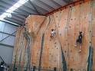
Another example is rock climbing. The artificial rock wall became popular when Recreational Equipment Inc (REI) installed man-made rock climbing walls in their 96 retail stores. While the expert rock climber wants the real thing, the novice rock climber can easily learn how to climb using the artificial climbing walls that are conveniently located close to home or the hotel. Even the expert climbers enjoy the climbing wall when the weather is adverse. www.rei.com.

For ice skaters, it is natural to skate on real ice --- whether indoors or outdoors. But now the rules have changed. There is a brand new, artificial skating surface called Xtraice. It looks like a white polyplastic cutting board that you would use in your kitchen to cut vegetables, but the sharp blades of ice skates do not damage the new skating surface. Xtraice was tested by the Spanish National Research Council and recommended by the Spanish Ice Hockey Association and the Danish Skating Union. Sixty (60) ice rinks are already installed in 17 countries using the artificial ice surface. www.xtraice.com.

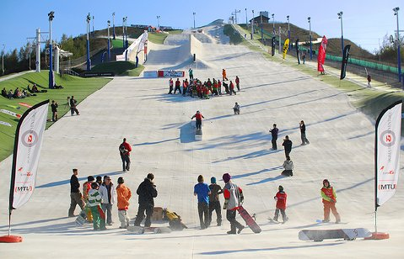
For snow skiers, it is traditional to ski on real snow during winter, but now you can ski on artificial material during summer. It is kind of nice to practice your snow-skiing turns during hot weather on man-made material that provides a realistic feeling of real snow.

Briton Engineering Developments of the UK is the maker of the high-tech synthetic ski and snowboard surface called Snowflex which is installed in more than 20 slope projects throughout Europe.

Dieter Sturm, founder of All-Season Extreme of Lake Geneva WI, heads Snowflex USA and has a major project at Liberty University’s new sports park in Lynchburg VA. The $3 million first phase of the project, scheduled to be in place by summer 2008, includes hiking & biking trails, a ski lift and a 500-foot Snowflex slope constructed from a monofilament fiber. “Year round skiing and snowboarding is the future,” according to Sturm. DSturmFX@aol.com.

For kayakers and rafters looking for natural whitewater rivers, you have to plan ahead to reach the back country at exactly the right time --- not always convenient and quite expensive for a short getaway. What about making some man-made improvements to natural rivers to make them useful to kayakers and rafters during the year? Great idea.

Two companies lead the way in doing this: Recreational Engineering & Planning of Boulder CO and Whitewater Parks International of Glenwood Springs CO. REP’s Scott Shipley and Gary Lacey have completed about twenty river projects, mostly in Colorado, where they created in-stream diversions and enhanced these rivers for kayakers and rafters. Their work resulted in tremendous economic impact for local communities. shipleyscott@cs.com.

WPI’s Bob Campbell took it a step further to build totally artificial whitewater river stadiums for the Summer Olympics in Sydney 2002, Athens 2004 and Beijing 2008. bob.campbell@whitewaterparks.com.

These natural river enhancements and totally man-made whitewater river stadiums led the way for the first commercial whitewater river park in the USA.

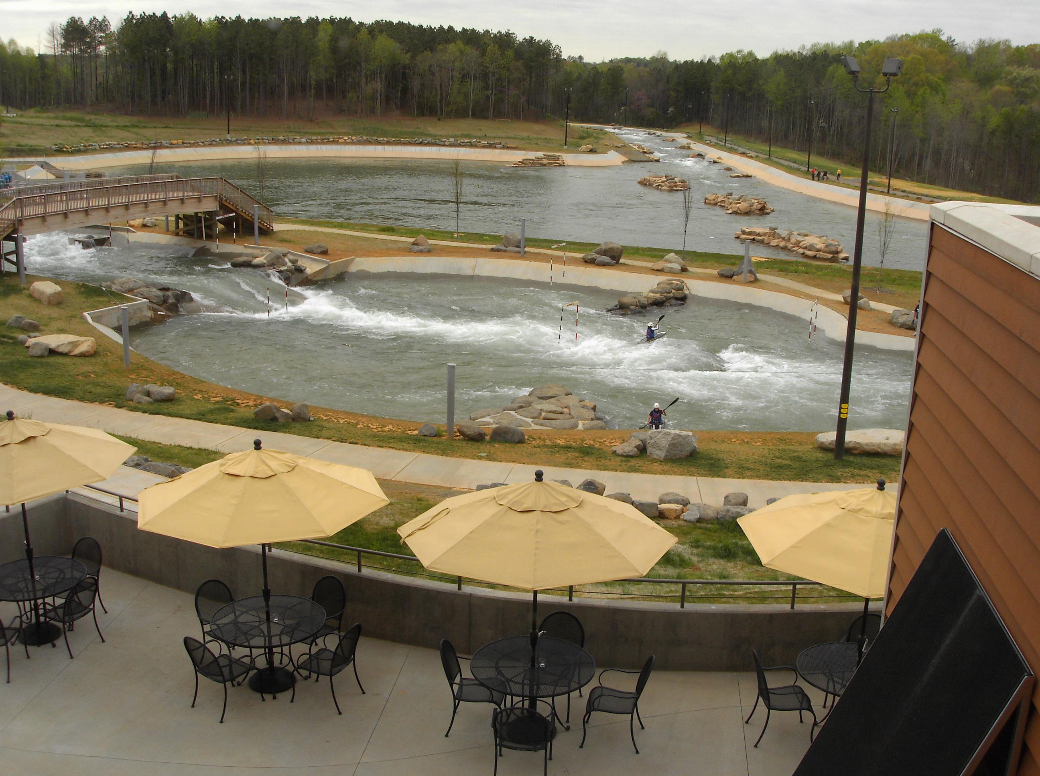
The US National Whitewater Center (USNWC) in Charlotte NC boasts the largest artificial river in the world --- a multi-channel waterway for kayakers and rafters that is at the heart of the 307-acre facility that includes a ropes challenge course, 11 miles of mountain biking & hiking, the largest man-made outdoor rock climbing wall in the country, a 20,000 sf conference facility, restaurant and retail shop.

For more information on the USNWC, contact resort master-planner Michael Williams (michael@liquiddesign.net ) of Liquid Design of Charlotte NC, whitewater designer-engineer Scott Shipley (shipleyscott@cs.com ) of Recreational Engineering & Planning of Boulder or USNWC executive director Jeff Wise (jeff@usnwc.org ), manager of the facility which opened in 2006.

The Adventure Sports Center International (ASCI) is the only other artificial recirculating whitewater riverpark in the USA. Located on 550 acres in McHenry MD at the top of WISP Ski Resort, this riverpark opened in May 2007 with a dual channel course and a 240-foot boat conveyor that connects the lower pond with the upper pond. For more, contact the McLaughlin Whitewater Design Group in Denver CO. www.mclaughlinwhitewater.com.

As a result of these new facilities, whitewater riverparks are now on the drawing boards in combination with other waterparks as part of mixed-use resort developments, such as Waveyard Adventure Resort in the conceptual stages for Mesa AZ.

For ocean surfers, finding the best natural waves in the world means visiting Hawaii, Tahiti, Indonesia and Australia at exactly the right time of year. In the USA, Pipeline and Sunset Beach on the north shore of Oahu rank among the highest --- followed by Blacks Beach, LaJolla, California; Cape Hatteras Region, North Carolina; Trestles Region, San Clemente, California; Malibu Beach, California; Sebastian Inlet Area, Central Florida; and Huntington Beach, California, also known as “Surf City USA.”

Skilled surfers may save up their money just to go to certain places around the world to ride the best waves and capture memories that will last a lifetime. Most surfers would be content to find a consistent wave nearby where they can work on their skills. But finding a consistent wave is difficult even for those enthusiasts who live near the ocean.

What’s the next best thing to a natural ocean wave? A man-made wave using wave generating equipment. The first artificial wave in the USA was Big Surf, which opened in Tempe AZ in 1969. During the 1980’s, hundreds of wave pools were built, but none had waves big enough to attract the skilled surfer --- until Typhoon Lagoon opened in 1989 at Walt Disney World in Orlando.

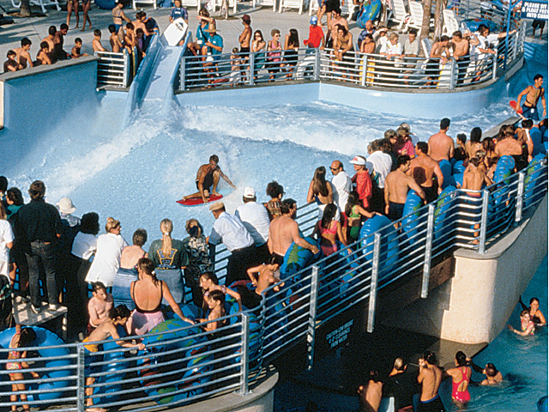
Today, the largest man-made wave pools are located in Kuala Lumpur, Orlando, Guatemala, Seoul, Botswana, Japan and West Edmonton Alberta. But not even the largest, Sunway Lagoon at 139,880 sf in Malaysia, was designed for the adventure sports enthusiast --- until Tom Lochtefeld invented the artificial wave in a box. When you can’t count on real waves, you can always find WaveLoch’s Flowrider (sheet wave in a box) and lots of people at WaveHouse in San Diego.

Ron Jon Surf Shop is building and testing the next generation artificial wave pool at Festival Bay Mall in Orlando. Using the pool’s shape and adjustable floor system to configure a variety of waves, the surf pool will generate up to 6 waves per minute and wave heights of 5 to 8 feet and ride lengths of 60 to 100 yards. The surf pool will cater to all skill levels from beginner to the experienced surfer and bodyboarder. www.ronjons.com

In the design phase, Waveyard Adventure Resort in Mesa AZ is the ultimate in a surf park as part of a mixed-use adventure resort destination. Developers Richard Mladick and Jerry Hug have interviewed all the wave generation experts to introduce the first surf park with 9 to 12 foot waves for the adventure sports enthusiast. www.waveyard.com

9. Every Outdoor Sport Will Have An Indoor Version

Many sporting activities --- golfing, rock-climbing, skiing, boarding, kayaking, rafting and surfing --- were part of natural settings that included mountains, rivers and oceans. Traditionally, many of these activities have been outdoor adventure sports. But sporting enthusiasts say it is hard to get away from work at the right time. It is difficult and expensive to travel to the coast when the perfect ocean wave is breaking or reach the backwoods when the whitewater river is cresting. So, now resort and attraction developers are bringing the adventure closer to the market. It seems that every natural setting has a made-man artificial version. And every outdoor sport has an indoor version located closer to home.

We have indoor golf, indoor rock climbing, indoor snow skiing, indoor skateboarding, indoor waveboarding. Outdoor waterparks were a mature industry, but when pioneer Stan Anderson, owner of Polynesian Resort in Wisconsin Dells WI, created the first indoor waterpark attached to a hotel, it started a whole new industry that is growing from 24% to 32% annually. Hotels with indoor waterparks now account for 169 properties nationwide with 55 more scheduled to open in 2008.

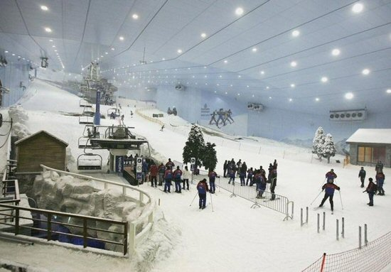
One of the most awesome examples of bringing adventure sports indoors is snow skiing.

Traditionally, one skis on real snow outdoors. No longer.

Now you can ski on real snow indoors. Currently, there are 40 snow domes worldwide, mostly in Europe and Asia.

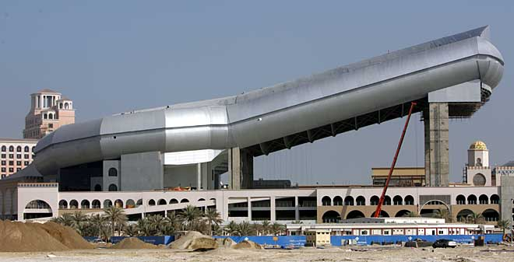
The $300 million Indoor Snow Dome in Dubai is just the biggest example of many (less expensive) snow domes yet to be built in Europe and North America.

Indoor snow domes using real snow are planned for Las Vegas and Riverhead, Long Island NY and Seoul Korea. Developers of the Las Vegas Wet Indoor Waterpark Resort & Casino announced they plan to build two hotels with 1400 rooms, a 350,000 sf indoor waterpark and an array of water rides including a wave rider, uphill water coaster, family raft slides, lazy river and a surfing attraction. In addition, Las Vegas Wet plans to construct an indoor snow dome.

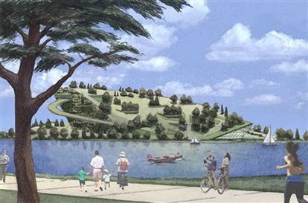
Tom Stewart, who heads Stewart International Marketing of Scotland, presented a plan to the Riverhead NY Town Board to build a $750 million destination resort with a 50-story indoor ski mountain, hotel and convention center. The proposed SnowValley Sports Park would be built on a 755-acre former Navy site and provide Olympic-quality skiing on real snow with a 425-foot vertical drop. The complex would also include a waterpark, whitewater rafting course as well as tennis, soccer and bike racing facilities --- another example of adventure sports going mainstream as part of mixed-use resort destination projects.

Mountain bikers will tell you it’s not about the bike so much as communing with nature, moving forward and being outdoors. Moab UT is a Mecca for mountain bikers. Other awesome biking destinations include Blue Mountain Nirvana in Tarrytown NY, South Mountain Trails in Phoenix AZ and The Flume at Incline Village NV. But now, you don’t need a mountain. You don’t even need to be outdoors.

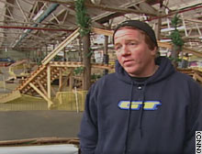
Ray’s Indoor Mountain Bike Park is the first and still the only indoor mountain bike park in the world. It’s located inside an old warehouse at 9801 Walford Road in Cleveland OH. Owner and designer Ray Petro opened his 97,000 sf indoor mountain bike park in late 2004. Ray decided he was sick of winter weather and built an indoor park that features all the joys of mountain biking, minus the nasty weather. Ray’s Indoor MTB Park draws bikers from the pro-level to Olympians to the after-work fun riders who want to practice their skills. The indoor MTB park attracts riders from North America, mostly from a 5-state region, and attracts visitors from around the world who want to copy his plan. Ray works with the Holiday Inn Cleveland Airport to provide packages that include lodging and indoor park passes. Holiday Inn rooms are ½ price for Ray’s customers. Go to www.raysmtb.com and click on Weekend Specials to get the code to give to Holiday Inn. From airport to hotel, it is 2.4 miles and from hotel to Ray’s Indoor MTB Park, it is 3.5 miles --- using the hotel’s free shuttle.

Another example of indoor mountain biking without a mountain is St Paul MN, home of the Red Bull Ride the Sky event. “St Paul has this crazy system of indoor skyways and covered walkways to keep people out of the cold in winter, and Red Bull put together an awesome MTB course completely indoors using the skyways and buildings,” according to writer Jeff Barber.

The Metropolitan Government of Seoul Korea is considering the construction of a sports theme park that will include a domed stadium with an indoor ski slope and a water rafting facility inside --- surrounded by an outdoor park with biking trails and performing arts facilities. Here we see several adventure sports clustered together in a mixed-use resort development. And we see the use of domed structures covering large spaces to bring outdoor sports indoors.

10. New Structures & Enclosures Cover Large Spaces Affordably

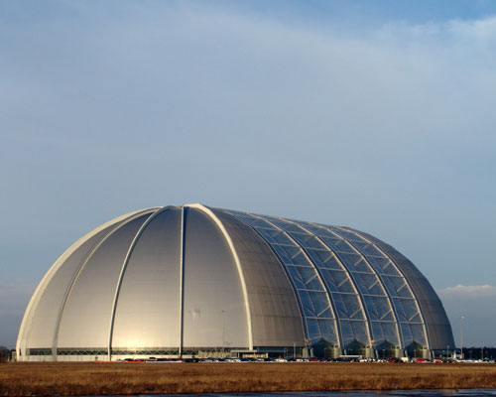
In the city of Brand, not far from where the Berlin Wall once stood, a former airship hangar houses Tropical Islands, a 700,000 sf indoor waterpark resort with sandy beach, lagoon, spa, fine dining and hotel. The huge resort, shown at right, is open 24/7, regardless of the weather outside, because it is covered.

Ocean Dome in Miyazaki, Japan is known as the world’s largest indoor waterpark, the size of three football fields or 322,700 sf, due to its fully-retractable roof, which is kept open when warm weather permits.

One of the largest shopping malls in the world has one of largest indoor waterparks in the world, the 217,000 sf World Waterpark at the West Edmonton Mall in Alberta, Canada.
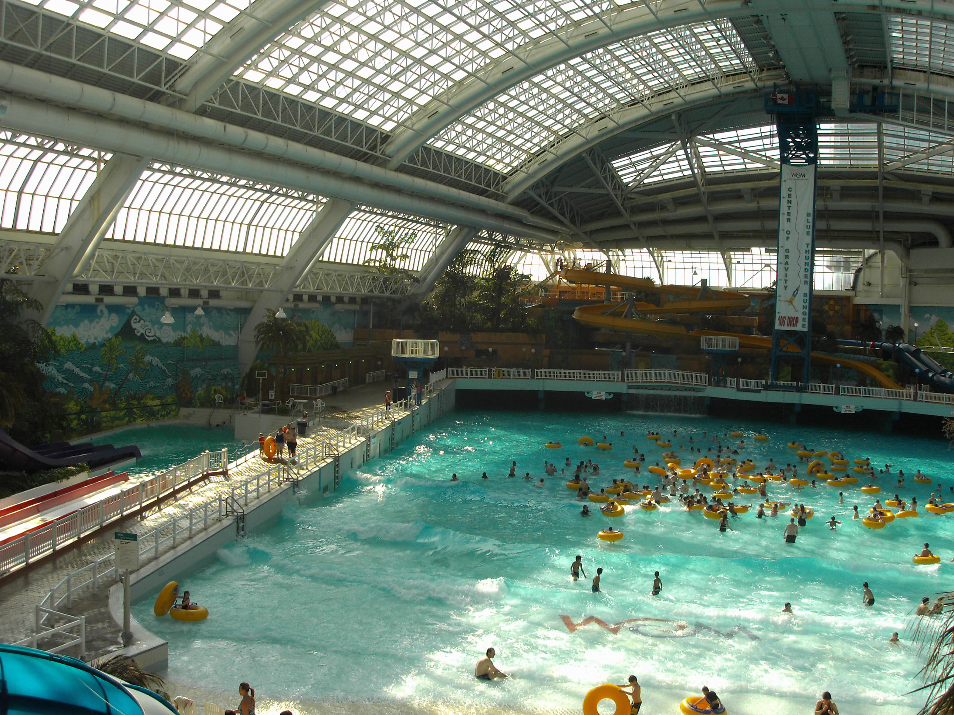
And when there is a blizzard outside, the glass roof allows natural light through and makes the 86-degrees inside seem tropical.

New technology now exists to convert, for example, a 7-acre outdoor waterpark into a 7-acre indoor waterpark with no supporting posts.

Covering large spaces now makes it possible for outdoor venues to expand their peak season from 100 days to 365 days a year. And the new high-tech structures are less costly than traditional materials. Using a transparent roofing system, the resort developer can create an economical indoor island paradise that is open to the sky all year long --- a big attraction for people that live in areas where it’s too cold, too hot or too rainy.

Basically, there are four ways to cover large spaces --- letting in the light and keeping out the weather --- perfect for indoor waterparks: (1) aluminum & glass, (2) thin shell concrete domes, (3) polycarbonate grid with texlon and (4) moveable roofing systems. Likewise, there are four major players one should consider:

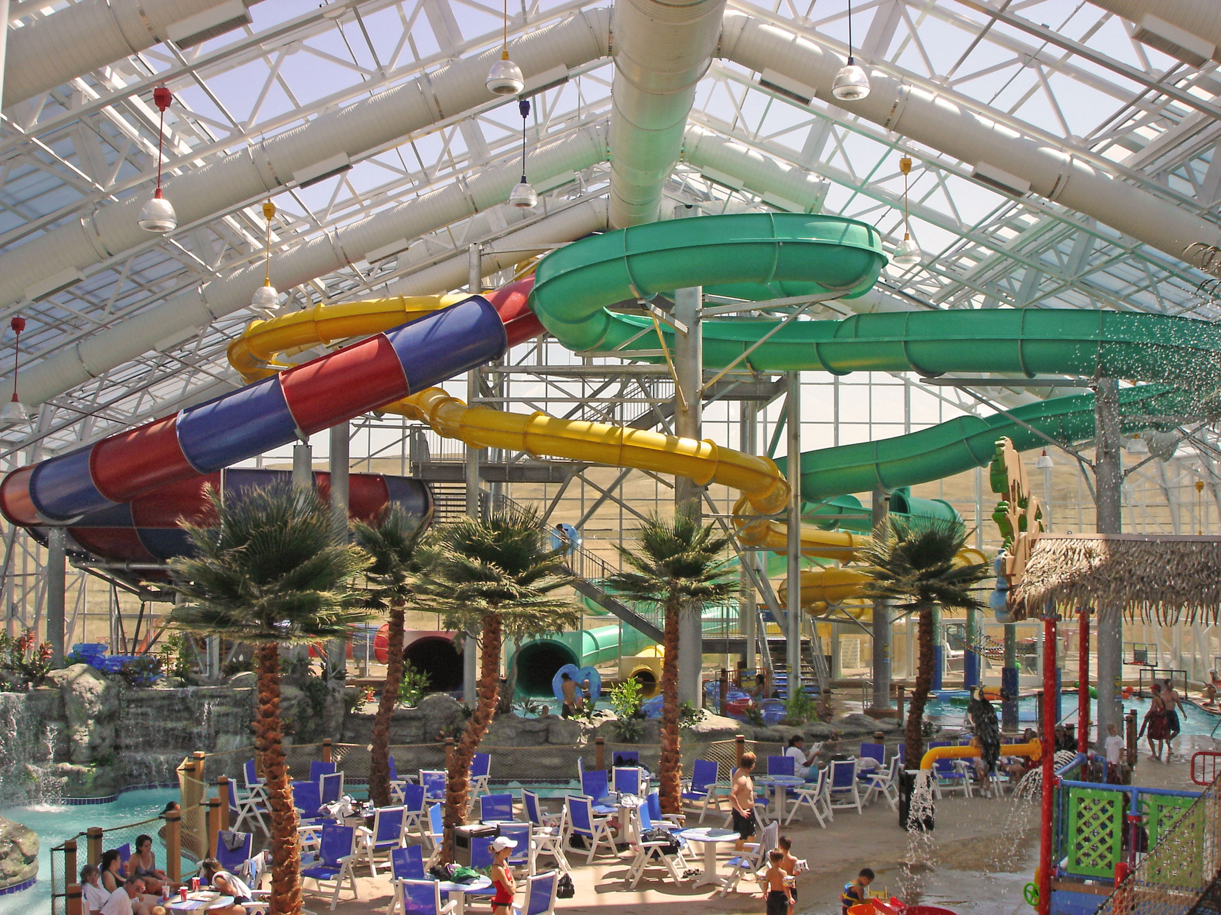
- Open-Aire Inc of Toronto can span up to 140 feet with their thermal aluminum structure. Open-Aire buildings can be all glazed or in-filled with other materials. These buildings are perfect for indoor waterparks, pool enclosures, restaurant patios or shopping mall concourses where the building owner wants to bring the outdoors in. Contact Dave Bolwerk in Cedarberg, WI at 262-675-6966 or email openairem@aol.com.

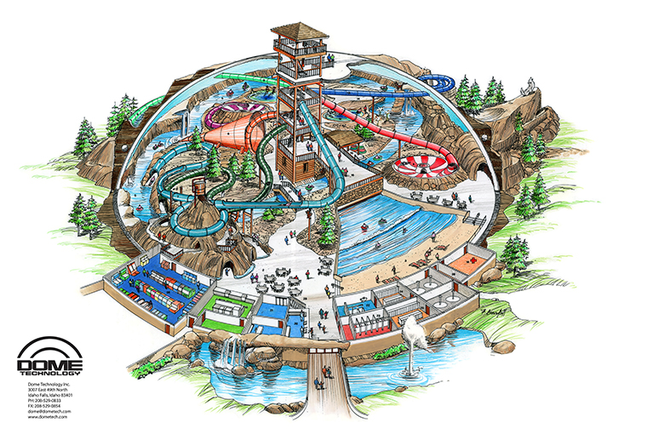
- Dome Technology Inc of Idaho Falls ID has built dozens of dome structures for industrial and commercial use around the world --- including churches, schools and homes. Large spaces can be sliced into the dome, letting in a maximum amount of light. Recently, the Holiday Inn Express in Toledo-Maumee OH opened its indoor waterpark using the dome structure. With no support posts, the waterpark layout is unencumbered, as water rides and slides hang from the ceiling of the dome. Contact Dan South at 208-529-0833 or email dan@dometech.com.

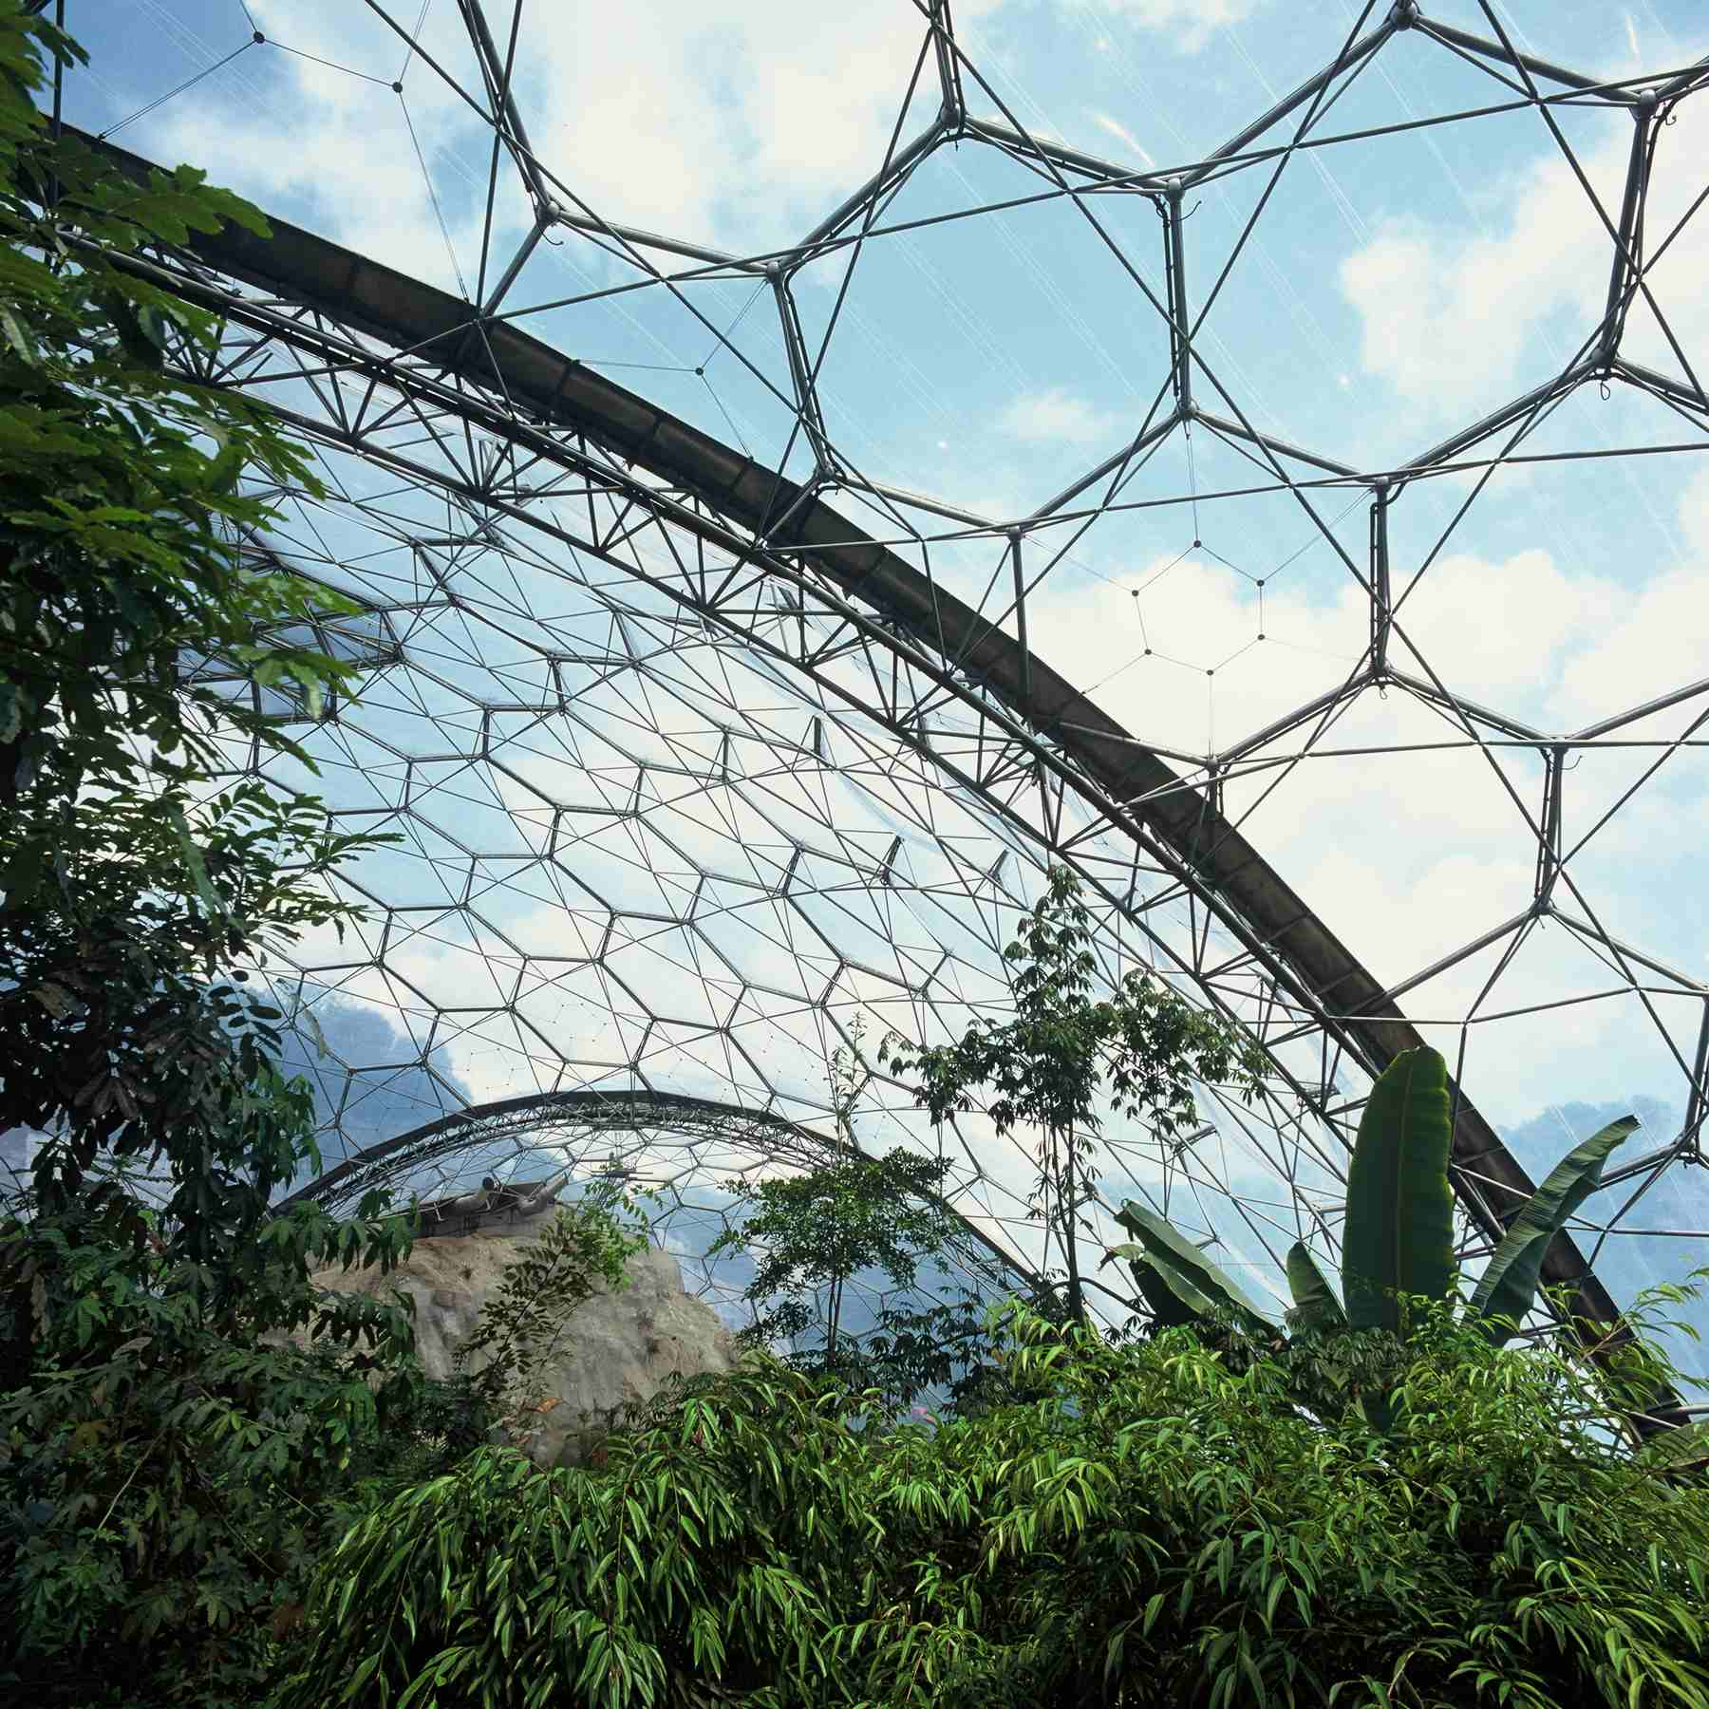
- Foiltec-Texlon Inc of Cohoes NY built the Biomes at Cornwall, England --- similar to the geodesic domes made famous by futurist Buckminster Fuller. Foiltec uses a polycarbonate grid system with several layers of texlon transparent materials that can withstand great snow loads and wind loads. In 2005, they completed the 42,000 sf pyramid-shaped indoor waterpark at Massanutten Ski Resort in McGaheysville VA. In 2006, they covered the 68,000 sf outdoor wave pool at Wilderness Resort in Wisconsin Dells WI and brought it indoors using texlon. And in 2007, the company used the foil roofing system in the waterpark expansion at Kalahari Resort in Sandusky OH. Contact Ken Ellis at 518-783-0575 or email kene@aquaticgroup.com.

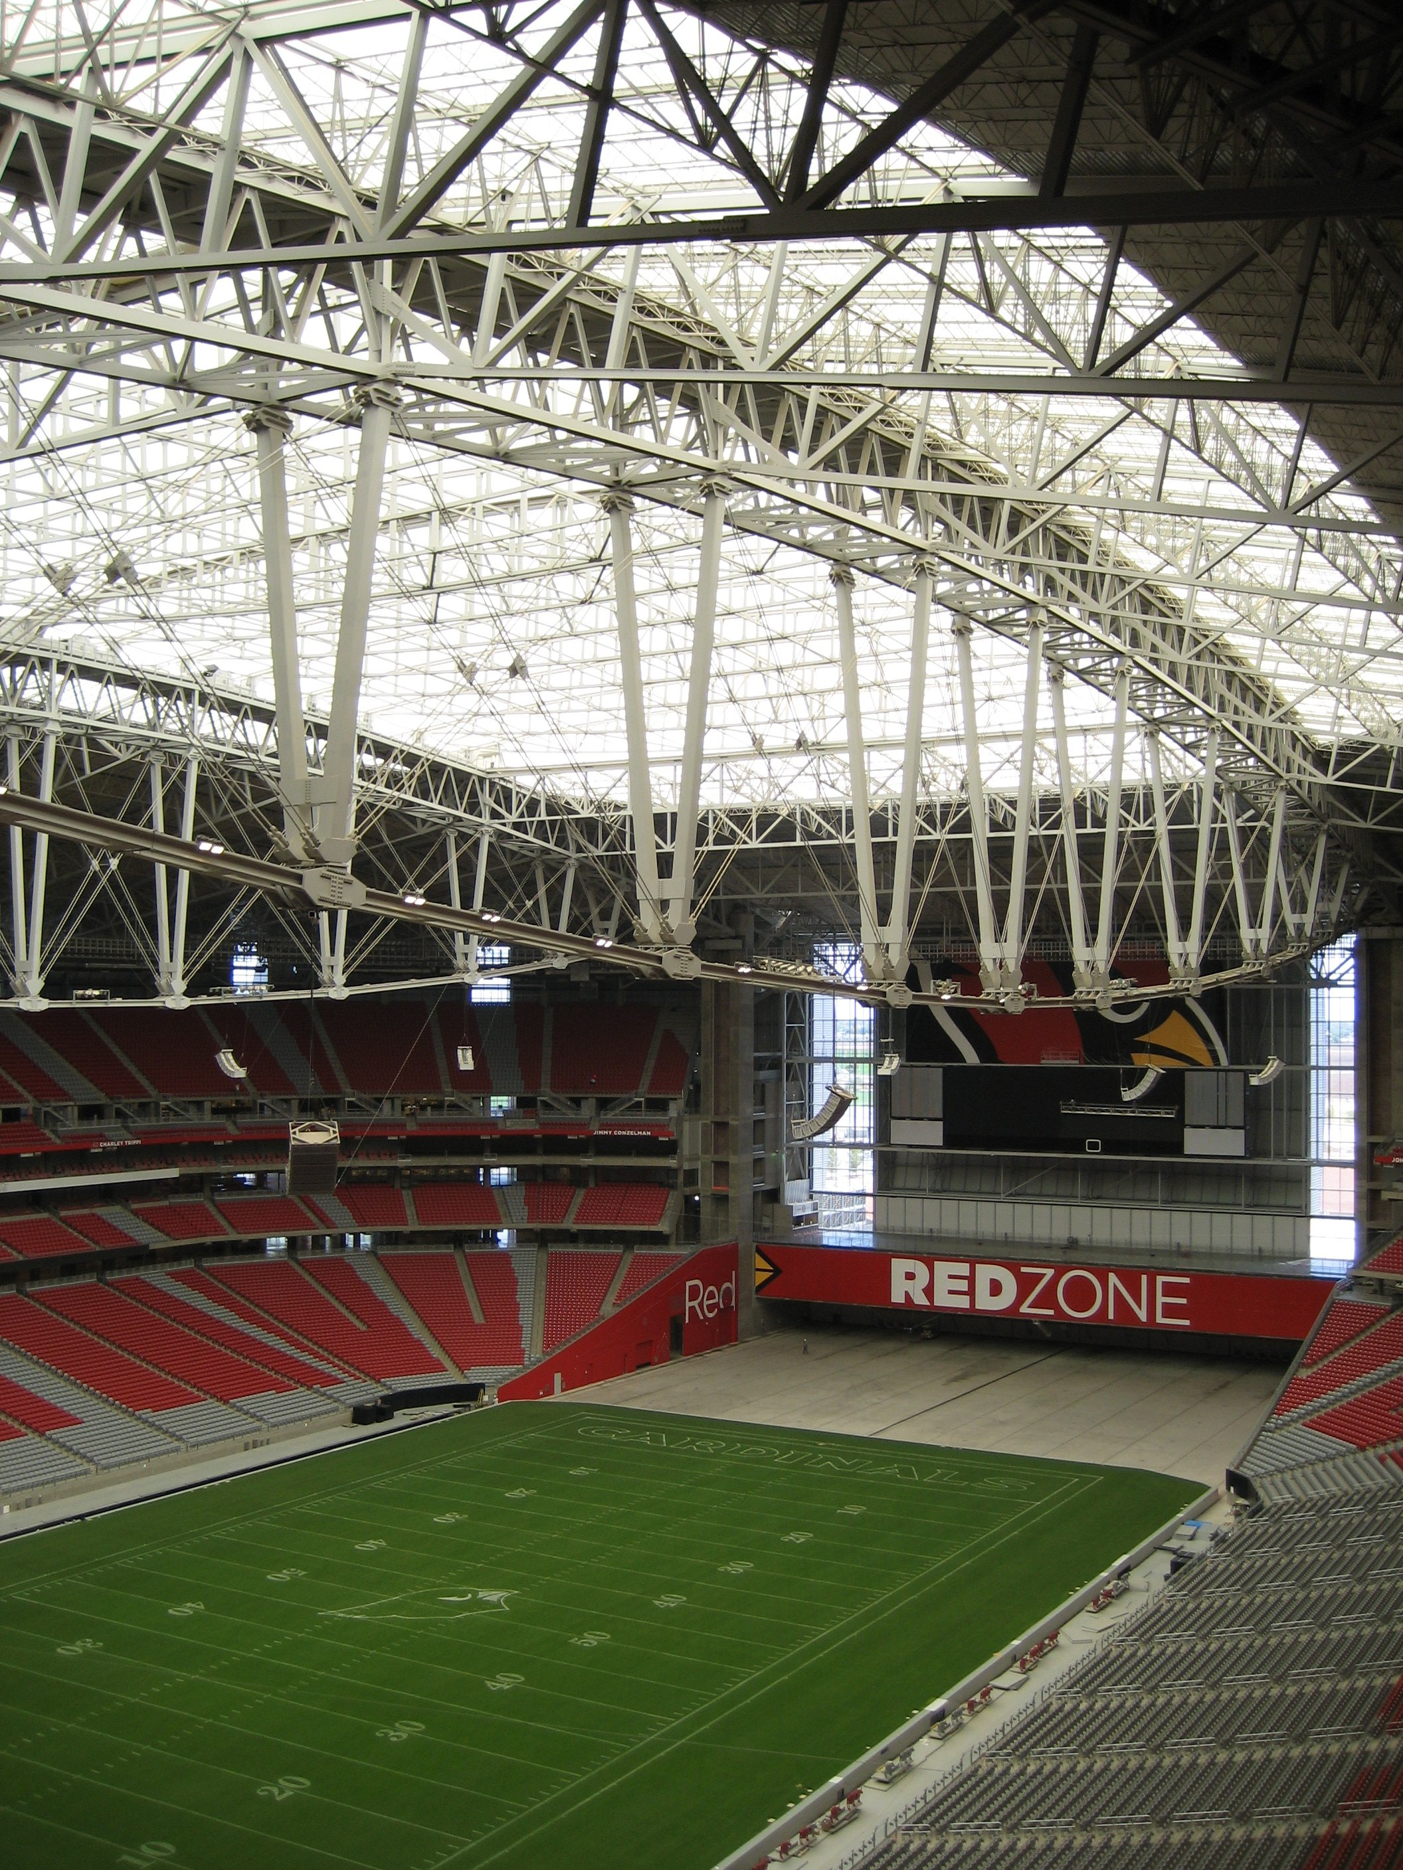
- Uni-Systems LLC of Minneapolis MN is the world leader in motion-technology for roofs, walls and floors of buildings designed for sports, entertainment and aviation. You can see their work at Reliant Stadium in Houston TX and Miller Park in Milwaukee WI. In 2007, they installed a retractable roof and playing field at the University of Phoenix Stadium in Glendale AZ. Their moveable roofs and walls make it possible to convert outdoor waterparks and amusement parks into flexible outdoor-indoor facilities that can generate revenue all year long, regardless of weather. Contact Pete Fervoy at 763-536-1407 or email pfervoy@uni-systems.com.

Possibility Thinking Results in Innovation

It’s not hard to predict the future of adventure sports resorts. Just imagine the impossible --- like snow skiing in summer or surfing in the middle of the desert.

Think about how to make artificial snow, or just imagine how to create a wave. Invent new equipment (skateboards, snowboards and wakeboards) that makes the old equipment (snow skis and water skis) seem dull.

Think about how to convert a winter resort into a year round resort. How about indoor skydiving? It is this type of possibility thinking that results in new business opportunities. Each innovation creates a new sporting activity, a demand for new indoor-outdoor facilities and an opportunity to capture revenues all year long --- thus eliminating the risk of seasonality and climate in a resort investment.

And if you cluster all these demand generators into a mixed-use regional destination project --- with lodging, recreation, entertainment, conference center, restaurants, nightclubs, retail shopping, offices and residential components --- you have a winning combination.


Jeff Coy, ISHC, is president of JLC Hospitality Consulting of Phoenix-Cave Creek AZ and certified by the International Society of Hospitality Consultants. For more information regarding adventure sports and resort feasibility, contact him at 480-488-3382 or email jeffcoy@jeffcoy.com. Or go to www.jeffcoy.com.

